Practical No.2

**Threads:**

**Write a program to work with a single thread.**

**Write a program to work with multi threads.**

**Write a multithreaded program that generates the Fibonacci sequence.**

Input:-

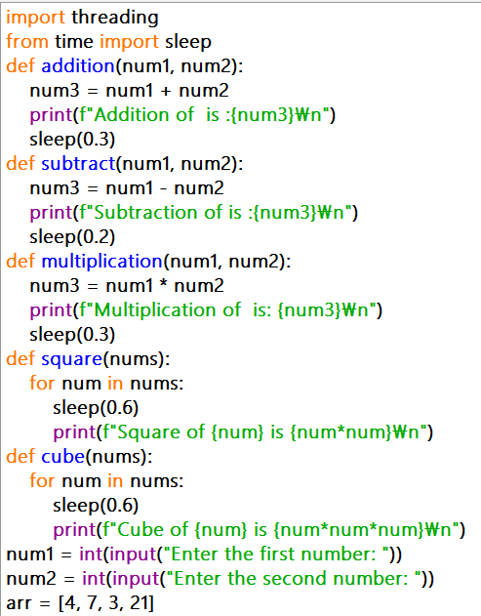

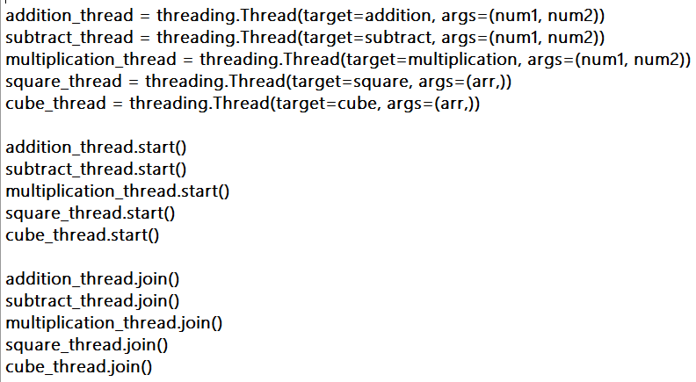

Output:-

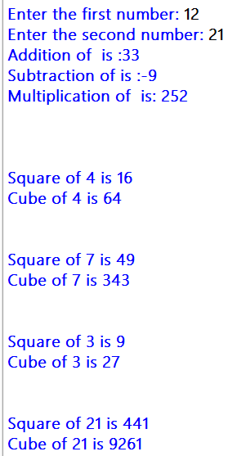

Input:-

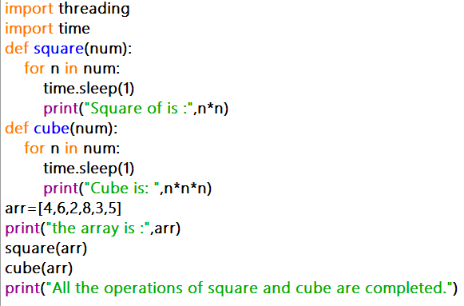

Output:-

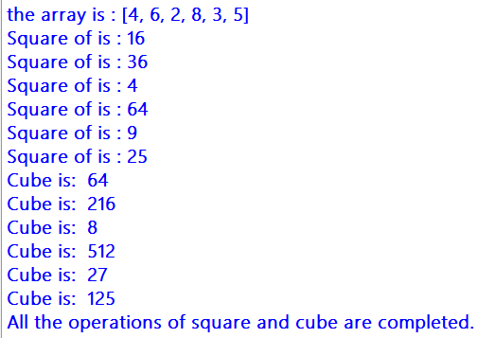

Input:-

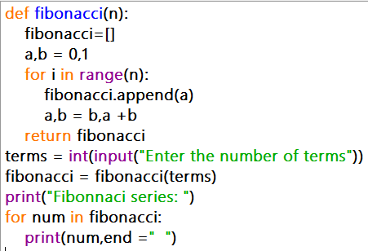

Output:-

